Lab G

Brandon Trinkle

Arizona State University

Course Number: IFT 202

Professor Gary Grindle

Feb 11, 2024

**Part 1**

Task 1

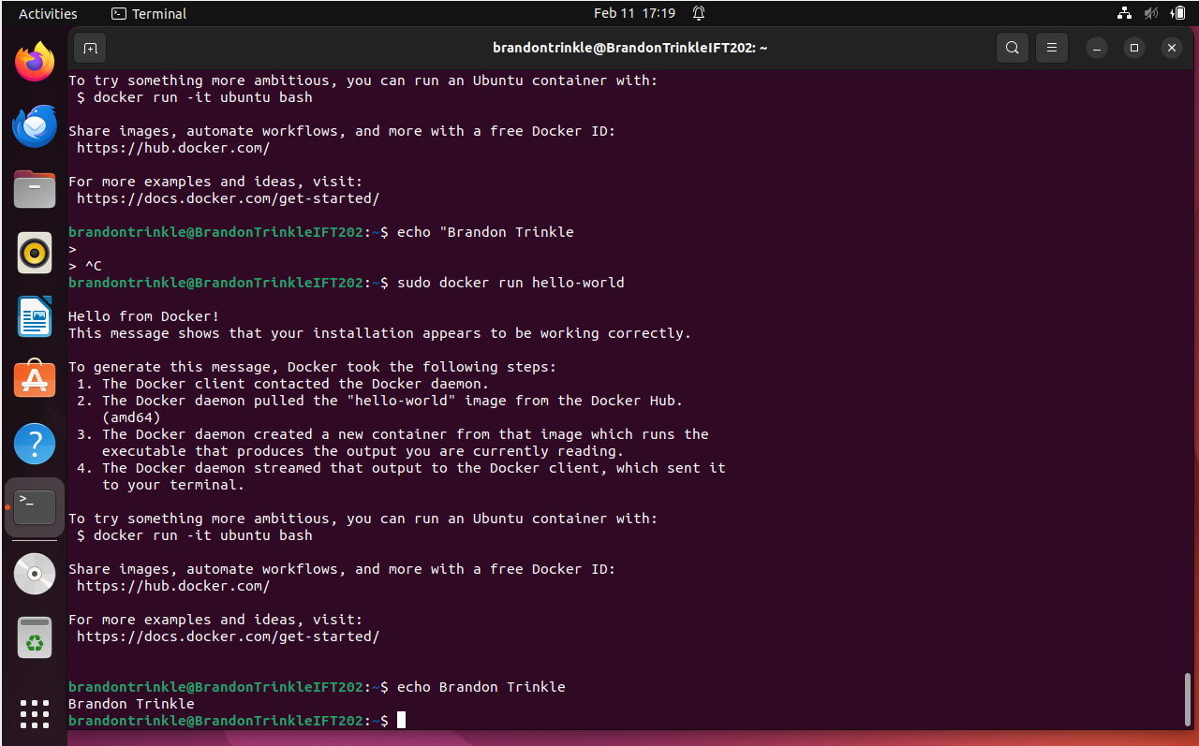

Task 2

## Task 3

Task 4

Task 5

